

**PROJECT FOR SQL MODULE**

**“Retail Inventory Management Analysing”**

*Institute Name: - I.T. VEDANT Education Pvt. Ltd*

*Name: - Pritesh Milind Manchekar*

*Address: - Manchekar.pritesh@gmail.com*

*Date of submission: -07th July 2024*

PROJECT AIM:

The aim of the Retail Inventory Management Analysis project is to optimize inventory management processes for a retail business. By analyzing past sales data, tracking inventory levels, and forecasting future demand, the project seeks to streamline operations, minimize stock outs, reduce excess inventory, and ultimately improve profitability.

**PROJECT OBJECTIVE:**

1. **Customer Analysis:**

* Segment customers based on demographics, purchasing behaviour, and geographic location.
* Analyze customer lifetime value (CLV) and retention rates to identify high-value segments.
* Determine customer preferences and tailor marketing strategies to increase engagement and loyalty.

1. **Product Performance Analysis:**

* Evaluate the sales performance of each product, including revenue generated and units sold.
* Identify best-selling products and analyze their contribution to overall sales.
* Assess product profitability and adjust pricing strategies accordingly.

1. **Inventory Management Analysis:**

* Evaluate current inventory levels and turnover rates for each product.
* Identify slow-moving and excess stock items to optimize inventory management.

1. **Sales Trends Analysis:**

* Analyze sales trends over time to identify seasonal variations and peak selling periods.
* Evaluate the impact of marketing campaigns and promotions on sales performance.
* Identify cross-selling opportunities and recommend product bundling strategies.

1. **Operational Efficiency Improvement:**

* Streamline order processing and fulfilment processes to improve efficiency and reduce lead times.
* Optimize store layouts and product placements to enhance the customer shopping experience.
* Identify opportunities for cost reduction and operational optimization.

1. **Comprehensive Analysis Report:**

* Detailed insights and actionable recommendations based on the analysis of customer, product, and sales data.
* Prioritized action plan for implementing recommended strategies to improve business performance.

1. **Data Visualization and Dashboards:**

* Interactive visualizations and dashboards to present key findings and trends in an easily understandable format.
* Visual representations of customer segments, product performance, and sales trends.

1. **Implementation Roadmap:**

* Step-by-step guide outlining the implementation process for recommended strategies.
* Timeline and resource allocation for executing identified initiatives.

IN THIS ER-DIAGRAM

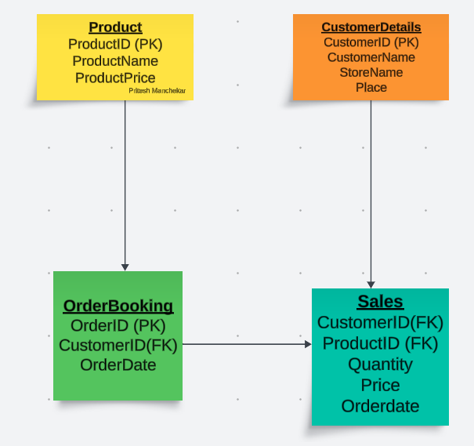

TABLE DESCRIPTION:

1. Customer Details:

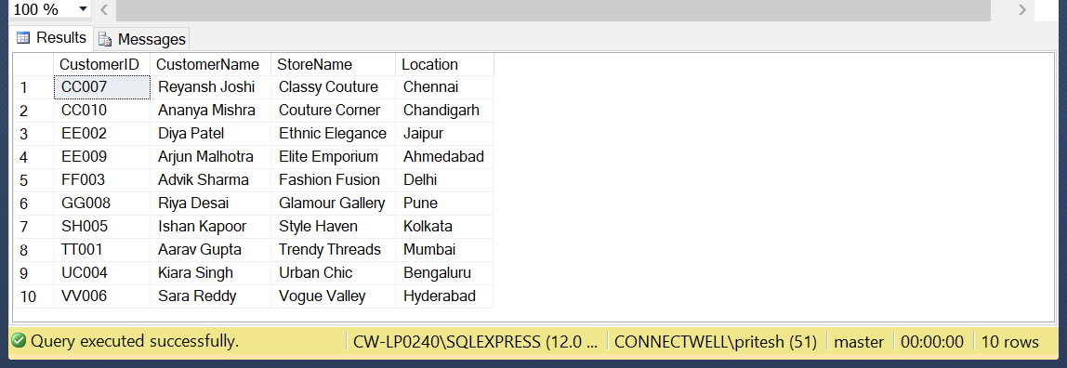

1. Product:

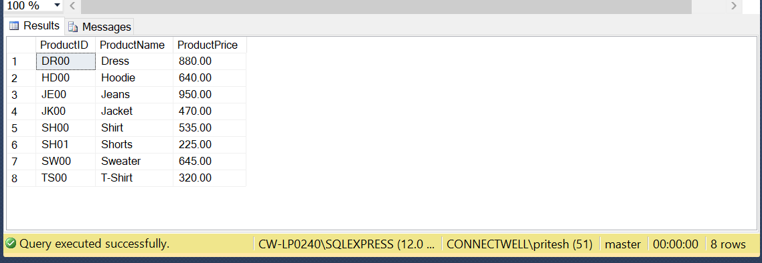

1. Order Booking:

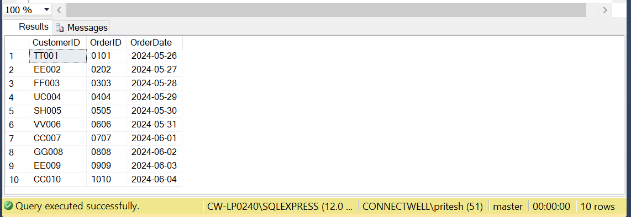

1. Sales :

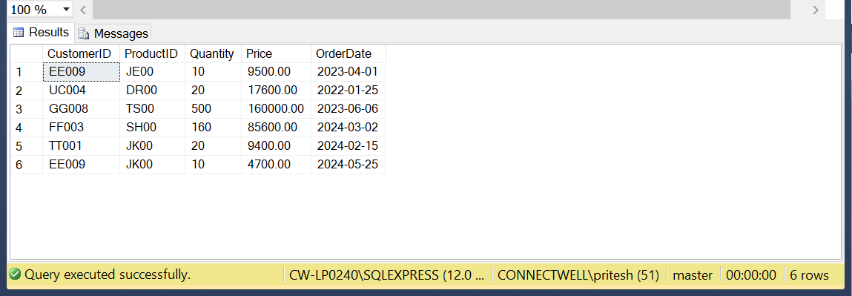

Command:

create database Inventory1

use Inventory1

CREATE TABLE CustomerDetails (

CustomerID VARCHAR(5) PRIMARY KEY,

CustomerName VARCHAR(50),

StoreName VARCHAR(50),

Place VARCHAR(50));

INSERT INTO CustomerDetails (CustomerID, CustomerName, StoreName, Place)

VALUES

('TT001', 'Aarav Gupta', 'Trendy Threads', 'Mumbai'),

('EE002', 'Diya Patel', 'Ethnic Elegance', 'Jaipur'),

('FF003', 'Advik Sharma', 'Fashion Fusion', 'Delhi'),

('UC004', 'Kiara Singh', 'Urban Chic', 'Bengaluru'),

('SH005', 'Ishan Kapoor', 'Style Haven', 'Kolkata'),

('VV006', 'Sara Reddy', 'Vogue Valley', 'Hyderabad'),

('CC007', 'Reyansh Joshi', 'Classy Couture', 'Chennai'),

('GG008', 'Riya Desai', 'Glamour Gallery', 'Pune'),

('EE009', 'Arjun Malhotra', 'Elite Emporium', 'Ahmedabad'),

('CC010', 'Ananya Mishra', 'Couture Corner', 'Chandigarh');

select * from CustomerDetails;

CREATE TABLE Product (

ProductID VARCHAR(5) PRIMARY KEY,

ProductName VARCHAR(50),

ProductPrice DECIMAL(10, 2));

INSERT INTO Product (ProductID, ProductName, ProductPrice)

VALUES

('TS00', 'T-Shirt', 320.00),

('JE00', 'Jeans', 950.00),

('DR00', 'Dress', 880.00),

('HD00', 'Hoodie', 640.00),

('SH00', 'Shirt', 535.00),

('SH01', 'Shorts', 225.00),

('JK00', 'Jacket', 470.00),

('SW00', 'Sweater', 645.00);

select * from Product;

CREATE TABLE OrderBooking (

OrderID VARCHAR(4) PRIMARY KEY,

CustomerID VARCHAR(5),

OrderDate DATE,

FOREIGN KEY (CustomerID) REFERENCES CustomerDetails(CustomerID));

INSERT INTO OrderBooking (CustomerID, OrderID, OrderDate)

VALUES

('TT001', '0101', '2024-05-26'),

('EE002', '0202', '2024-05-27'),

('FF003', '0303', '2024-05-28'),

('UC004', '0404', '2024-05-29'),

('SH005', '0505', '2024-05-30'),

('VV006', '0606', '2024-05-31'),

('CC007', '0707', '2024-06-01'),

('GG008', '0808', '2024-06-02'),

('EE009', '0909', '2024-06-03'),

('CC010', '1010', '2024-06-04');

select * from OrderBooking;

CREATE TABLE Sales (

CustomerID VARCHAR(5),

ProductID VARCHAR(5),

Quantity INT,

Price DECIMAL(10, 2),

OrderDate DATE,

FOREIGN KEY (CustomerID) REFERENCES CustomerDetails(CustomerID),

FOREIGN KEY (ProductID) REFERENCES Product(ProductID));

INSERT INTO Sales (CustomerID, ProductID, Quantity, Price, OrderDate)

VALUES

('EE009', 'JE00', 10, 9500.00, '2023-04-01'),

('UC004', 'DR00', 20, 17600.00, '2022-01-25'),

('GG008', 'TS00', 500, 160000.00, '2023-06-06'),

('FF003', 'SH00', 160, 85600.00, '2024-03-02'),

('TT001', 'JK00', 20, 9400.00, '2024-02-15'),

('EE009', 'JK00', 10, 4700.00, '2024-05-25');

select * from Sales;

Alter queries:

1. Add Discount Column to Sales Table:

Ans - ALTER TABLE Sales

ADD Discount DECIMAL(5, 2);

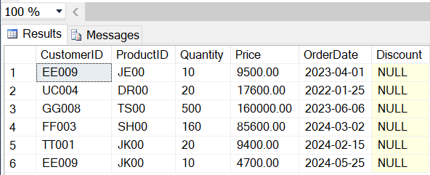

1. Modify OrderDate Column in OrderBooking Table to Datetime

Ans- ALTER TABLE OrderBooking

ALTER COLUMN OrderDate DATETIME;

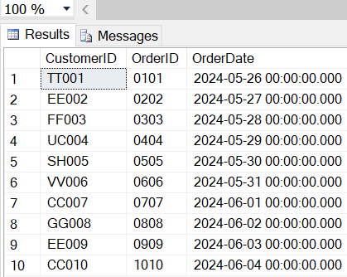

1. Drop ProductName Column from Product Table?

Ans- ALTER TABLE Product

DROP COLUMN ProductName;

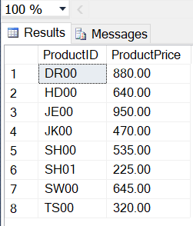

1. Find Customers with No Orders?

Ans- SELECT CustomerID, CustomerName FROM CustomerDetails

WHERE CustomerID NOT IN (SELECT DISTINCT CustomerID FROM OrderBooking);

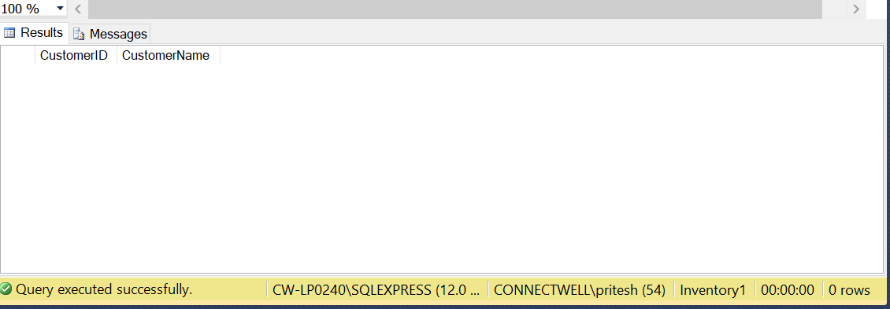

1. If there's a need to update the price of a specific product (for example, updating the price of 'Jeans' to 980.00)

Ans- UPDATE Product SET ProductPrice = 980.00 WHERE ProductID = 'JE00';

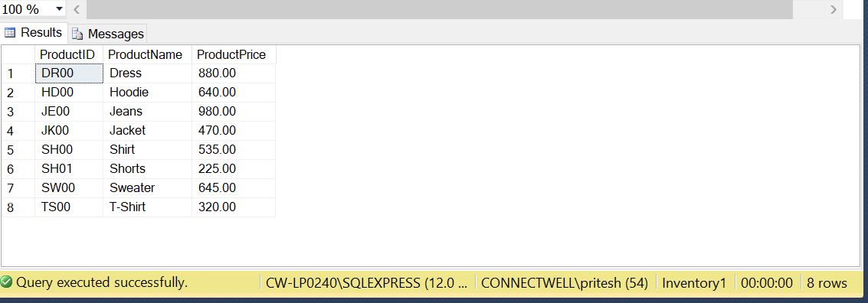

Joins queries:

1. **Retrieve CustomerID, CustomerName, OrderID, and OrderDate for customers who have placed orders.**

Ans- SELECT cd.CustomerID, cd.CustomerName, ob.OrderID, ob.OrderDate

FROM CustomerDetails cd

INNER JOIN OrderBooking ob ON cd.CustomerID = ob.CustomerID;

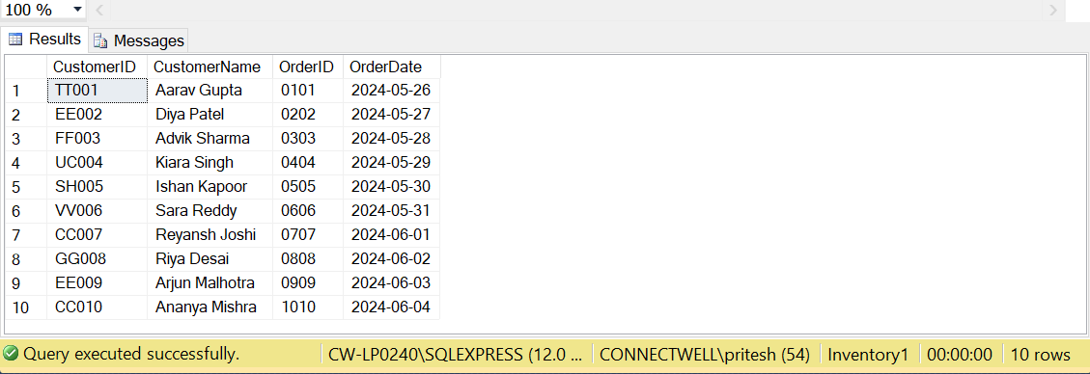

1. **Retrieve CustomerID, CustomerName, and OrderID from CustomerDetails for all customers, including those who haven't placed any orders.**

Ans- SELECT cd.CustomerID, cd.CustomerName, ob.OrderID

FROM CustomerDetails cd

LEFT JOIN OrderBooking ob ON cd.CustomerID = ob.CustomerID;

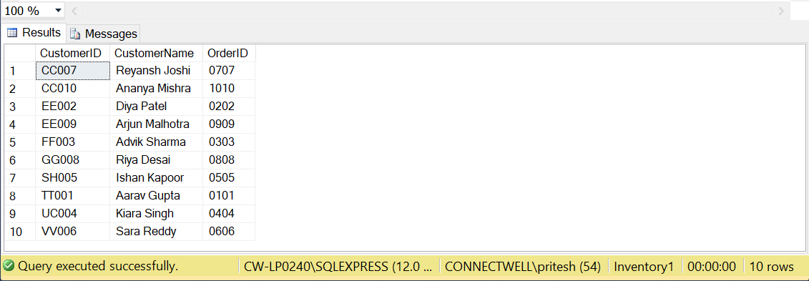

1. **Retrieve CustomerID, CustomerName, and Place for customers who have placed orders in 2024.**

**Ans-** SELECT cd.CustomerID, cd.CustomerName, cd.Place

FROM CustomerDetails cd

INNER JOIN OrderBooking ob ON cd.CustomerID = ob.CustomerID

WHERE YEAR(ob.OrderDate) = 2024;

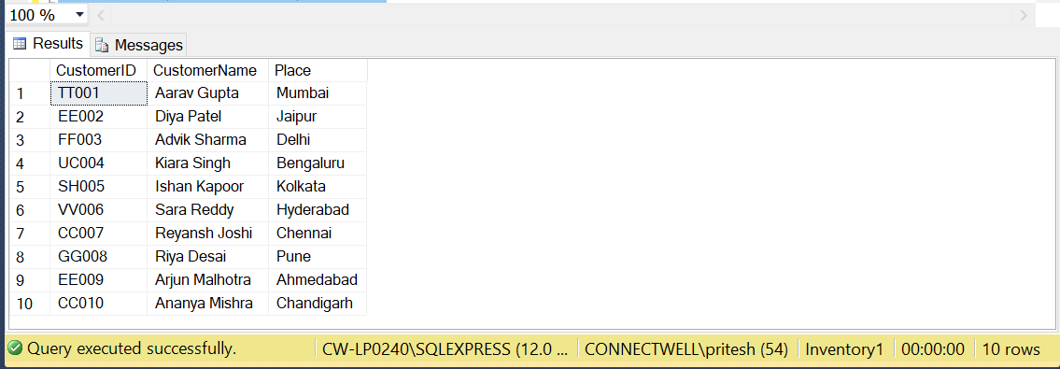

1. **Retrieve CustomerID, CustomerName, and CustomerID of customers who share the same StoreName.**

Ans- SELECT c1.CustomerID, c1.CustomerName, c2.CustomerID AS SharedCustomerID

FROM CustomerDetails c1

INNER JOIN CustomerDetails c2 ON c1.StoreName = c2.StoreName

WHERE c1.CustomerID <> c2.CustomerID;

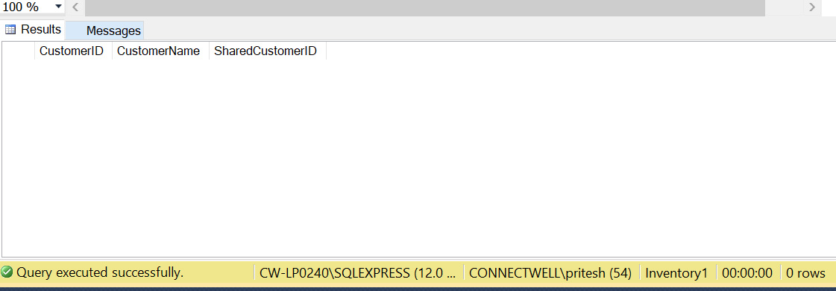

1. **Retrieve CustomerName, ProductName, Quantity, and Price for all sales transactions.**

**Ans-**  SELECT cd.CustomerName, p.ProductName, s.Quantity, s.Price

FROM Sales s

INNER JOIN CustomerDetails cd ON s.CustomerID = cd.CustomerID

INNER JOIN Product p ON s.ProductID = p.ProductID;

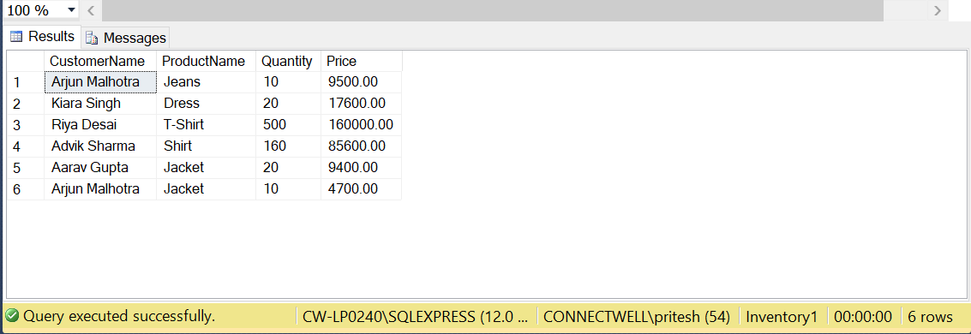

Conclusion:

• **Customer Analysis**:

* Customers are segmented across various demographics and geographic locations, indicating a diverse customer base.
* Further analysis of customer lifetime value (CLV) and retention rates is recommended to identify high-value segments and improve retention strategies.
* Tailoring marketing strategies based on customer preferences can enhance engagement and loyalty.

• **Product Performance Analysis**:

* Product sales vary significantly, with some products like T-Shirts (TS00) and Dresses (DR00) showing higher demand.
* Pricing strategies should be adjusted based on product profitability to maximize revenue and sales volume.

• **Inventory Management Analysis**:

* Current inventory levels and turnover rates vary across products, highlighting potential areas for optimization.
* Identification and management of slow-moving and excess stock items are crucial to streamline inventory operations.

• **Sales Trends Analysis**:

* Sales trends exhibit seasonal variations, with spikes during certain periods such as promotions or specific months.
* Marketing campaigns and promotions significantly impact sales performance, suggesting the need for targeted campaigns during peak periods.

• **Operational Efficiency Improvement**:

* Streamlining order processing and fulfillment processes can improve efficiency and reduce lead times.
* Optimizing store layouts and product placements can enhance the overall shopping experience and drive sales.

• **Conclusion**:

* The project has provided valuable insights into customer behavior, product performance, and operational efficiency.
* Actionable recommendations include refining marketing strategies, optimizing inventory levels, adjusting pricing strategies, and enhancing operational processes.
* Implementing these recommendations is expected to improve overall business performance by reducing costs, increasing sales, and enhancing customer satisfaction.

